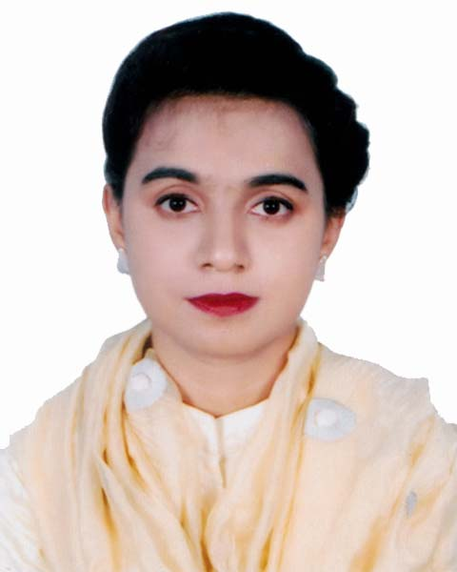

**Curriculum Vita**

**Of**

**Fatema Tuj Johora**

**5/3/E Paikpara, Ansarcamp**

**Mirpur-1.Dhaka-1216**

**Contact No:01989386029**

**E-mail:zharna623@gmail.com**

**Career Objectives**

Willing to work in a challenging & creative environment to build up a career with committed & dedicated people, responsibility in an environment of dynamic professional skills in order to explore myself fully and realize my potential to ensure ongoing organizational growth and success.

**Education Details**

**Master of Business Administration (M.B.A):**

**Major:** Human Resource Management (Running)

**Institution:** Jahangirnagar University

Year: 2019 may to continue

**Bachelor of Business Administration (B.B.A):**

**Major**: Human Resource Management

**Institution:** Bangladesh University of Business & Technology (BUBT)

CGPA: 3.75

Passing Year: 2017(1stFebruary)

**Higher Secondary certificate (H.S.C):**

Group: Business Study

**Institution**: Dhaka City College

GPA: 5.00

Passing Year: 2011

**Secondary School Certificate (S.S.C)**

Group: Business Study

**Institution**: Kallyanpur Girls’ School & College

GPA: 5.00

Passing Year: 2009

**Computer Skills**

* Skilled in Microsoft Office, Operating Systems.
* Very acquainted with Internet and some primary level Security analysis software.

**Language and Communication Skills**

* Capable of communicating fluently in English & Bengali in both oral & written forms
* Skillful in presentation and communication

**Social Activities:**

■ Helped in fundraising for poor street children

■Helped to collect money for underprivileged people

■Volunteered for BUBT club

**Special Qualifications:**

* Self-motivated, quick learner
* Enthusiastic, personable
* Can work under pressure and able to do multi-tasking
* Completed a course on Microsoft Office of 6 months from Sheikh FazilatunnesaMujibMohila Technical Training Centre, Dhaka
* Completed a course on Spoken & Phonetics from Mentors

**Experiences:**

■ Right now doing job at Japan Marketing and Consultancy Limited as a Customer Service IN Charge (since September 2019)

Job Responsibilities: (!) Make roaster for customer service executive (!!) Maintain Facebook page (!!!) Check CSE’s reply section (iv) communicate with customer, take order and make sure delivered

■Have an experience as a Senior Executive at Ichiban Study Link (Japanese Consultancy Firm) from April, 2018 to August 2019.

Job Responsibilities: (!) Counseling students and guardians,(!!) visa processing, (!!!) Documents checking

■Have an experience as a junior officer (5 months) at Digital world Communications Ltd (Online Sales & Marketing)

■Have an experience of doing a part time job at Unixpress Consultancy firm as a counselor Executive (5 months)

■ Have an experience of 3 months in doing work at Doreen Garments (as an internee)

Job Responsibilities: (!) Handling workers grievance with a view to reducing it.

(!!)Work as a communication bridge between floor Management & workers

(!!!)Conducting exit interview, survey on different issues as per management requirement

(!v) To look after compliance matter & to ensure industrial safety

**Personal Details**

Father’s Name : Md. JasimUddin

Mother’s Name : MinaJasim

Date of Birth : October 31, 1994

Nationality : Bangladeshi

National ID No : 1454422781

Home Phone : 01515244982, 01679602303

Religion : Islam

Marital Status : Single

Present Address : 5/3/E,Paikpara, Ansarcamp

Mirpur-1.Dhaka-1216

Permanent Address : Village: Gachahar;Post office: Ranirbandar;

Police Station: Chirirbandar; District: Dinajpur

**References**

**1. Hossen Md. RagibShahrear 2. Md. Rafiqul Islam Samrat**

General Manager (E/M) Executive Director

Ichiban Study Link Anti Corruption Associated Organization

[01795-539580](https://www.google.com/search?q=ichiban+study+link+address&oq=ichiban+study+link+address&aqs=chrome..69i57.7942j0j7&sourceid=chrome&ie=UTF-8) 01711595693

**Signature**

(FatemaTujJohora)